CSCE 548 – Project 2 Overview
Name: Myra Walker
Project: BodySculptApp
Language: C++
Database: PostgreSQL
Server Library: cpp-httplib

1. Project Description
The purpose of this project was to extend the Project 1 database and data access layer into a fully functional backend application. The application models a fitness tracking system called BodySculptApp, which allows users to track workouts and meals. The system includes business logic, a service layer, and a console-based client for testing.
The application uses a layered architecture consisting of:
- Models – represent database entities
- Data Access Layer (DAL) – handles database queries
- Business Layer (Services) – enforces business rules
- HTTP Service Layer – exposes REST endpoints
- Console Client – used to test the services
The backend communicates with a PostgreSQL database using the libpqxx library, and HTTP requests are handled using the cpp-httplib library.

2. Prompt Used to Generate Code
In a previous chat labeled: Branch · Full Stack - CSCE 548 - Project, you helped me complete phase 1 of my project. The instructions for phase 1 are included in attached images. These are the instructions I gave you to help me complete phase 1:
Help me complete the first phase of my semester long project with step by step instructions. C++ will be the programming language of choice. My project idea is a body sculpting app that keeps track users' workout and diet details in order to help them sculpt the body of their dreams.

Now, I want you to help me complete phase 2 of my project. I would also like to add the optional logging functionality. The instructions, ERD, and solution explorer (showing how the app's files are organized) are also included in the attached images.

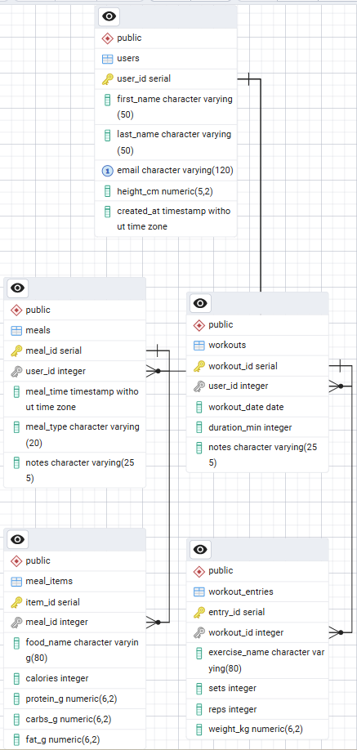
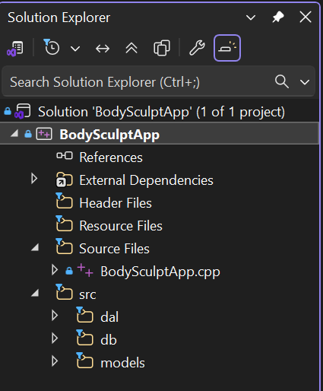
NOTE: The missing screenshots are the screenshots of the Project 1 and Project 2 instructions.

3. Technologies Used
The following technologies were used to build the project:
- C++ (Visual Studio 2022)
- PostgreSQL
- libpqxx for database access
- cpp-httplib for the HTTP server
- GitHub for version control
- Console client for service testing
- Custom logging system for application events

3. System Architecture
The project follows a layered architecture:
Models
Models represent the data structure of each database table.
Examples:
- User
- Workout
- WorkoutEntry
- Meal
- MealItem
Each model corresponds directly to a table in the PostgreSQL database.

Data Access Layer (DAL)
The DAL handles direct interaction with the database.
Examples:
- UserDAL
- WorkoutDAL
- MealDAL
- MealItemDAL
Responsibilities of the DAL:
- Insert records
- Retrieve records
- Update records
- Delete records
- Map database rows to C++ model objects

Business Layer (Service Classes)
The business layer enforces application rules before interacting with the DAL.
Examples:
- UserService
- WorkoutService
- MealService
Responsibilities include:
- Validating input
- Enforcing business rules
- Logging operations
- Calling the appropriate DAL methods

HTTP Service Layer
The service layer exposes HTTP endpoints that interact with the business layer.
Implemented endpoints include:
GET /users
POST /users
GET /workouts
POST /workouts
GET /workouts/{id}/entries
POST /workouts/{id}/entries
GET /meals
POST /meals
GET /meals/{id}/items
POST /meals/{id}/items
These endpoints allow the client to create and retrieve records through HTTP requests.

Console Client
A console-based client was created to test the services. The console menu allows the user to perform the following operations:
1. Create User
2. Get All Users
3. Create Workout
4. Get All Workouts
5. Create Workout Entry
6. Get Workout Entries
7. Create Meal
8. Get All Meals
9. Create Meal Item
10. Get Meal Items
The console client sends HTTP requests to the local server running on:
http://localhost:8080

4. Database Tables
The PostgreSQL database includes the following tables:
Users
Stores basic user information.
Fields include:
- user_id
- first_name
- last_name
- email
- height_cm

Workouts
Stores workout sessions performed by users.
Fields include:
- workout_id
- user_id
- workout_date
- duration_min
- notes

Workout Entries
Stores exercises within a workout.
Fields include:
- entry_id
- workout_id
- exercise_name
- sets
- reps
- weight_kg

Meals
Stores meals logged by users.
Fields include:
- meal_id
- user_id
- meal_time
- meal_type
- notes

Meal Items
Stores foods included in a meal.
Fields include:
- item_id
- meal_id
- food_name
- calories
- protein_g
- carbs_g
- fat_g

5. Business Rules Implemented
The service layer validates data before inserting records into the database.
User Rules
- First name cannot be empty
- Last name cannot be empty
- Email must contain "@"
- Height must be a positive value

Workout Rules
- User ID must exist
- Duration must be greater than zero
- Workout date must be provided

Workout Entry Rules
- Workout ID must exist
- Sets must be positive
- Reps must be positive
- Weight cannot be negative

Meal Rules
- User ID must exist
- Meal time must be provided
- Meal type must be one of:
- breakfast
- lunch
- dinner
- snack

Meal Item Rules
- Meal ID must exist
- Food name cannot be empty
- Nutrition values cannot be negative

6. Logging
A logging utility was implemented to track application events. Logs are written to the file:
app.log
Example log entries include:
[INFO] Application starting
[INFO] Server started on port 8080
[INFO] POST /users
[INFO] GET /users
[INFO] POST /workouts
[INFO] POST /meals
Logging helps track requests and identify errors during development and testing.

7. Testing
All services were tested using the console client.
The following tests were performed:
- Creating users
- Retrieving all users
- Creating workouts
- Retrieving workouts
- Creating workout entries
- Retrieving workout entries
- Creating meals
- Retrieving meals
- Creating meal items
- Retrieving meal items
Screenshots of these tests were captured and included in the submission PDF.
Additional screenshots were taken from PostgreSQL to verify that records were correctly inserted into the database tables.

8. Use of AI in Development
AI tools were used to assist with generating portions of the project code and troubleshooting implementation issues.
AI was used to help:
- Generate service layer structure
- Generate console client logic
- Create HTTP endpoint handlers
- Suggest improvements to error handling
- Debug database connection issues
- Resolve compilation and linking errors
- Improve code organization
However, manual modifications were required to ensure the code worked correctly within the project structure.
Examples of manual fixes include:
- Correcting function signatures
- Adjusting DAL method calls
- Adding missing fields such as meal_time
- Fixing database authentication errors
- Correcting nullable parameter handling
- Resolving PostgreSQL constraint violations

9. AI Effectiveness
AI assistance significantly accelerated the development of the service layer and console client. It helped generate working code quickly and provided guidance when debugging errors.
However, AI-generated code still required manual review and adjustment to integrate properly with the existing database schema and project structure. Several issues, such as database constraints and parameter handling, required developer intervention.
Overall, AI served as a helpful development assistant but did not replace the need for debugging, testing, and architectural decisions by the developer.

10. Conclusion
Phase 2 successfully expanded the Phase 1 database project into a functional backend application. The system now includes a service layer, business logic validation, HTTP endpoints, logging, and a console client for testing.
All required functionality was implemented and tested successfully, and the application correctly interacts with the PostgreSQL database to store and retrieve workout and meal tracking data.

